**Please start by saving this file with the name:** UESTC4006P_Interim_year

***\*\*\*\* Please add appropriate course code***

|  |  |
| --- | --- |
| Student Name |  |
| Student Matriculation Number |  |
| UESTC Student Number |  |
| Degree programme | B.Eng. of Communication Engineering |
| Academic year | 2020-21 |
|  |  |
| Placement Company  (if appropriate) | UESTC |
| Working Title of Project | The development of a USB Spectrometer for optical frequencies |
| Name of First Supervisor | Hasan Abbas |
| Name of Second Supervisor |  |
| **Declaration of Originality and Submission Information** | *I affirm that this submission is all my own work in accordance with the University of Glasgow Regulations and the School of Engineering requirements*  Signed (Student) : |

**Your report should be NO more than 8 pages in length and include the below subject headings and incorporated within this document:**

**Work done so far including thorough literature review**

**Literature Review**

**Introduction**

In this project, I use a diffraction grating to spread a beam of compact polychromatic light into serval monochromatic one, so that knowing the principles and characteristics of the grating is important. Because the diffraction grating is quite a mature technology, I mainly choose to read some textbooks about optical physics instead of academic papers.

There are two main parts that I will explain in the main body of this literature. The first one is the grating equation which helps me design the light path and the structure of the spectrometer. And the other one is the resolution equation; it helps me choose the right grating according to my requirement.

**Main Body**

**grating equation**

In this project, one of the core components is the diffraction grating, it is a kind of optical instrument which usually shapes like a plate with the periodic structure on its surface and it can split the incident light into serval beams to a different direction by diffracting. The direction of these beams is depending on the distance between the microstructure of the grating and the wavelength of the incident light so that the different frequency components of the light can be separated and detected by the sensor respectively later and the relationship between these factors can be explained as the grating equation.

There are two kinds of grating, reflective and transmissive type. The principles are similar among two types because the transmissive one is much cheaper than the other one, I choose to apply it in this project. Assuming the grating is idea and transmissive, there are a set of splits of spacing *d* which is wider than the wavelength of the targeting light. When a monochromatic light incident on the grating, each split will act as a single split causing single-split diffraction, while at the same time, all the diffraction light beam will cause the multi-split interference. For any giving point in the space, the distance to every split is varied, so the phase of the beams is different causing accentuation and attenuation at a different point. With these two reasons, the effect of the diffraction can be explained as the result of multi-split interference modulated by single-split diffraction.







By applying the knowledge from physics textbooks, we could get an equation that could predict the light direction by the wavelength , incident light angle , the distance between splits , and the order of the maximum beams .

The equation could also be written as:

**Resolution equation**

When a polychromatic light beam goes through the grating, different frequencies part will spread into multiple monochromatic beams. However, when two components have a similar wavelength, their direction will be close and hard to distinguish each beam. So that in this condition, we define that the resolution is the target beam wavelength divided by the minimum distinguished wavelength offset , i.e.:

As what we learn from the Rayleigh Criterion when one beam’s maximum point lines up with the other one’s minimum point, the distance between two beams is the smallest to distinguish them.



By the knowledge I mentioned in the first part, the maximum beam equation is:

And the minimum one is: ( is the number of splits on the grating)

After some calculation, we could get the relationship between the resolution and the characteristics of the grating:

**Conclusion**

In conclusion, after the reading and summarise the result, now I have two important equation: and . And now I could use these equations to design the structure of the spectrometer, buy the grating with correct factor and further building.

**Reference**

[1] MILLER, I, 2000.PHYSICS for SCIENTISTS and ENGINEERS.3rd ed. Prentice-Hall

[2] Lord Rayleigh, F.R.S. (1879). "Investigations in optics, with special reference to the spectroscope". Philosophical Magazine. 5. 8 (49)

[3] "Introduction to Diffraction Grating" (PDF). Thor Labs. Retrieved 30 December 2020. Available at: https://www.thorlabs.com/catalogpages/802.pdf

[4] @Chemistforall, "High-resolution DIY spectrometer" (PDF). Retrieved 30 December 2020. Available at: <https://publiclab.org/i/26339.pdf>

**Work done so far**

Based on the research and reading I mentioned in the literature review, I drew a rough draft about the whole design.

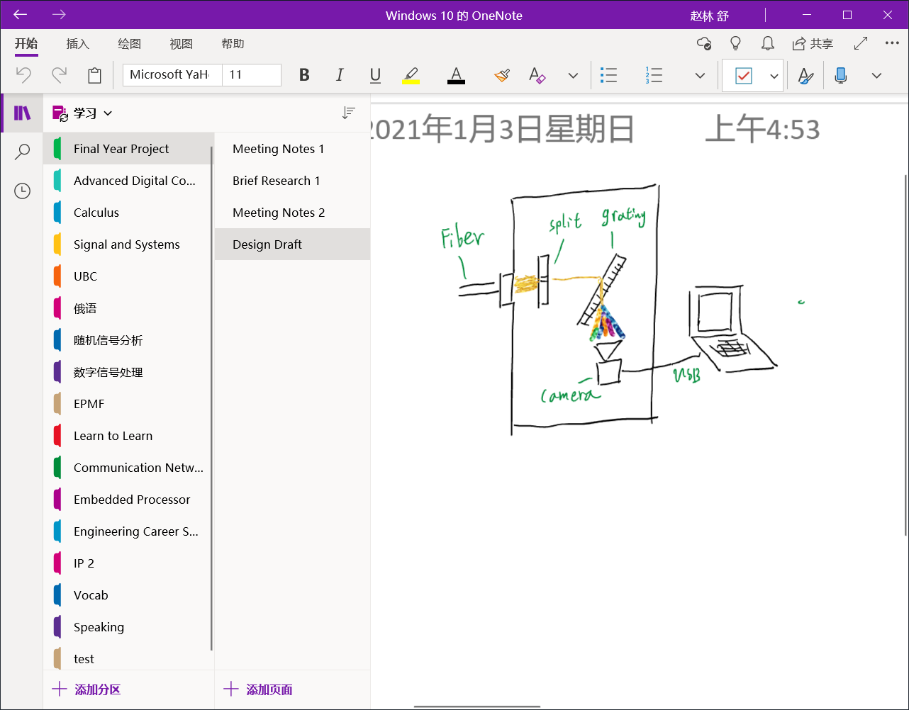

Then I contact with the shopper on Taobao and found some good value and quality component.

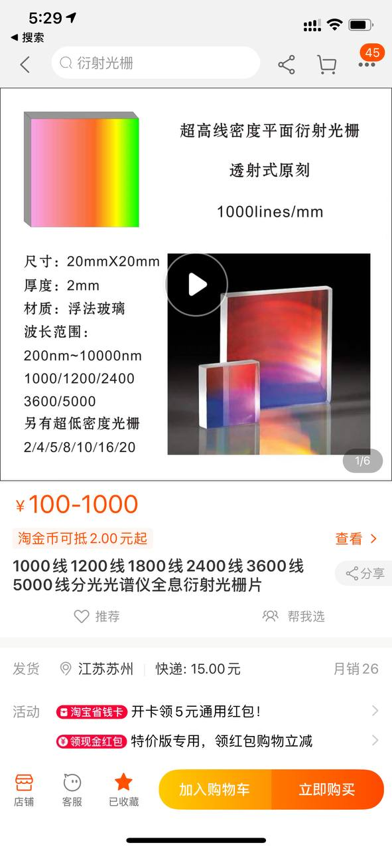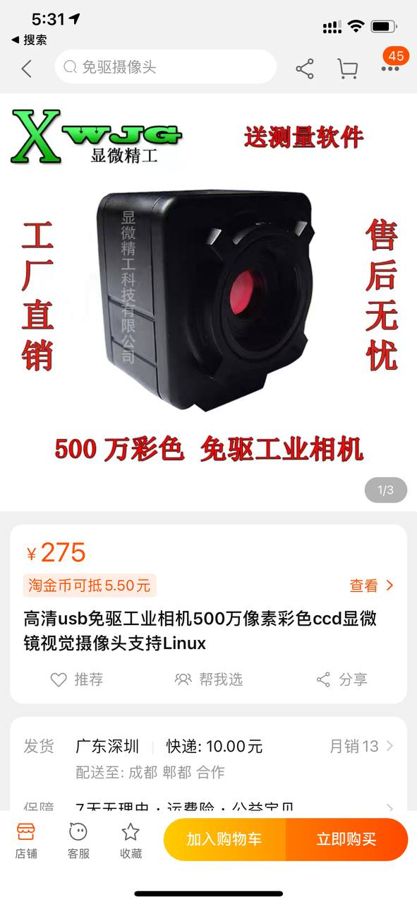

Finally, I learn some online courses about how to use SOLIDWORKS to build a 3D model.

**Conclusions from initial work**

At this stage, I have finished the theoretical part of the project, and now I have a very clear way to design the hardware structure. Then I contacted the shoppers on Taobao to ask for the information about the instruments and components that I need, and I was ready to write a purchase list. And then I try to learn the use of SOLIDWORKS from online material, so that I could build my 3D models and 3D-print then by using the 3D-printer at the Lab.

However, the original plan is greatly delayed due to the final exams. From the origin Gantt chart, I delayed about 2-3 weeks, which means that I must hurry up to finish the left steps and maybe compress the time remained for the final report.

**Work to be done**

There are still many things to be done, the first thing is to purchase the camera and the optical components like a diffraction grating. Then I need to build a 3d model in the SOLIDWORKS and 3D-print them. After this, I could assembly the whole hardware part and begin to adjust the details.

After the hardware building, the software part will start. Firstly, I will test the spectrometer by using some free software online. And then I am going to build a signal processing software by Python and a GUI for convenient usage. After all these, I will test both the hardware and software to make sure everything working and calibrate them to minimize the error.

And the last things are writing the final report and preparing for the oral presentation.

**Revised Gantt Chart**

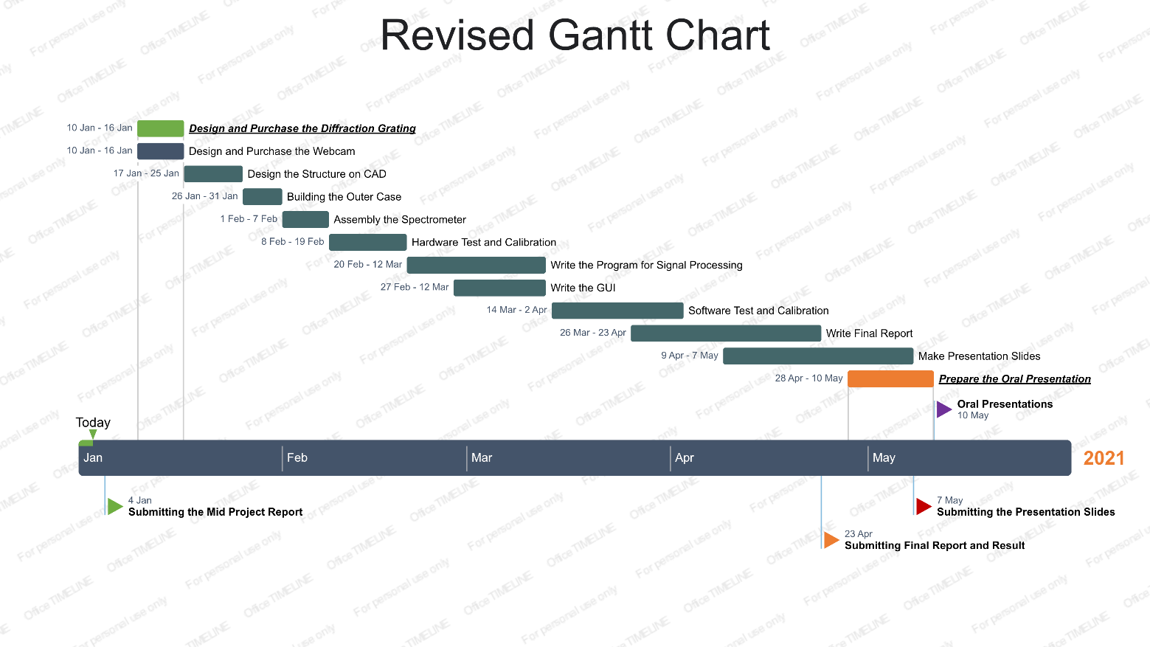

**Deadlines for submission of this report**

Please upload this report via the Moodle page by the deadline mentioned in Table 1 of your project handbook.

***Comments from your Second Supervisor will be made via Moodle or via email.***

**Feedback from Second Supervisors:** Second supervisors may provide their feedback by adding comments directly on Moodle taking into account the questionnaire below **or** by filling out the below form and uploading it to Moodle.

|  |  |
| --- | --- |
| Name of Second Supervisor | Jihong Yan |

|  |  |  |  |  |
| --- | --- | --- | --- | --- |
| Was the report satisfactory? | Yes |  | No |  |
|  |  |  |  |  |
| Are you satisfied with the (updated) scope of the project? | Yes |  | No |  |
|  |  |  |  |  |
| Is the revised plan feasible? | Yes |  | No |  |
|  |  |  |  |  |
| Would you like to give any suggestions/recommendations? | Yes |  | No |  |

***Please write your comments in the space provided below:***

|  |
| --- |
|  |

**Signature: Date:**